



Literary devices can be used in a variety of text types **to create effects**, e.g. to add emphasis, describe vividly, evoke associations and persuade readers.

*Use the literary devices provided to spice up the writing.*



Although studies show electric cars are more environmentally friendly than petrol cars, less than 3% of all vehicles sold in 2020 worldwide were electric.

Write a letter to the editor of *Hong Kong Post*.

* Discuss why sales of electric vehicles are so low.
* Suggest what can be done to attract more people to drive these vehicles.

*Writing topic taken from Paper 2 of the 2021 HKDSE English Language Examination ©HKEAA*

Writing topic taken from Paper 2 of the 2021 HKDSE English Language Examination ©HKEAA

**Topic**



*Comparison (simile & metaphor)*

*Can you convey the meaning of the phrase ‘have remained flat’ by making an appropriate comparison?*



To many drivers, petrol cars outcompete electric cars in terms

of convenience. While drivers of petrol cars can simply fuel

their vehicles in any petrol filling station when necessary, accurate estimation and advance planning on the time and

locations of charging is required for drivers of electric cars to avoid interruptions to their journeys. This is especially vital when drivers are going on the highways or taking intercity trips as stopping in the middle of the journey unexpectedly is definitely unpleasant (   
 ). That explains why the sales of electric cars have remained flat (   
 ) despite the efforts of governments worldwide and car manufacturers to promote the use of electric cars.

**2. Body Paragraph**

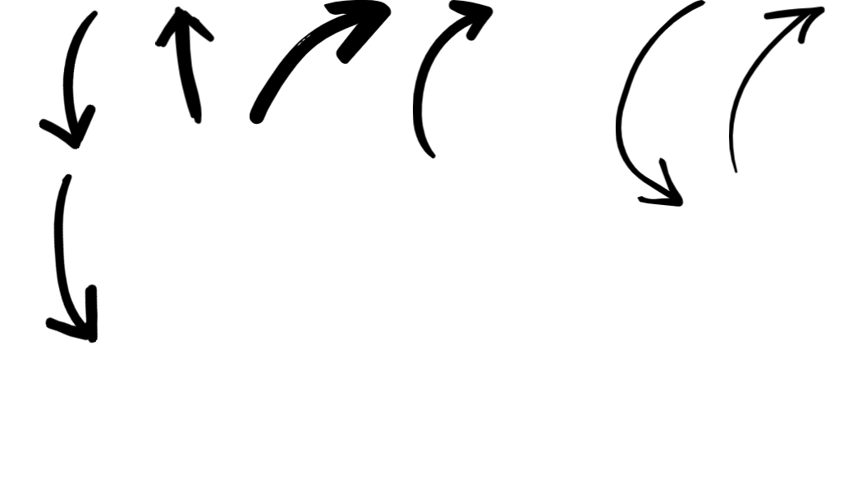



**Hyperbole**

*Can you exaggerate the unpleasant experience to catch readers’ attention (e.g. using superlatives such as ‘the worst xxx’)?*

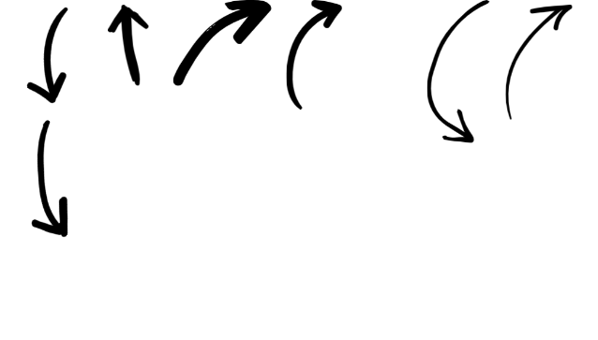

1. **Opening**

In recent years, manufacturers of electric cars have been keen to promote their products. However, less than 3% of all vehicles sold in 2020 worldwide were electric. While petrol cars continue to sell like hot cakes, electric cars remain unpopular among drivers ( ).  
   
   
In the following, I am writing to discuss why electric vehicles are regarded as undesirable by drivers and suggest some measures to make them more attractive.







**3. Closing**

To conclude, driving electric cars is a good alternative to driving petrol cars.





Comparison (simile & metaphor)

The idiomatic expression ‘sell like hot cakes’ is a simile used to describe things sold in large quantities quickly.

*What similar expressions can be created to describe the unpopularity of electric cars? Can you think of a kind of food that is so unappealing that no one will buy?*



Personification

*Can you add human qualities to the unsold electric cars? You may describe how they sit and feel while waiting to be bought.*



In the closing paragraph, the following literary devices can be used to reinforce important points/messages:

* Parallelism (e.g. Driving electric cars will be more attractive if…, if…, and if…)
* Alliteration (e.g. buy a better car)
* Rhetorical questions (e.g. Why don’t we switch to electric cars now?)

Alliteration and rhetorical questions are used particularly in the last sentence to catch attention or provoke thinking. Can you complete the last paragraph using at least one of these literary devices?



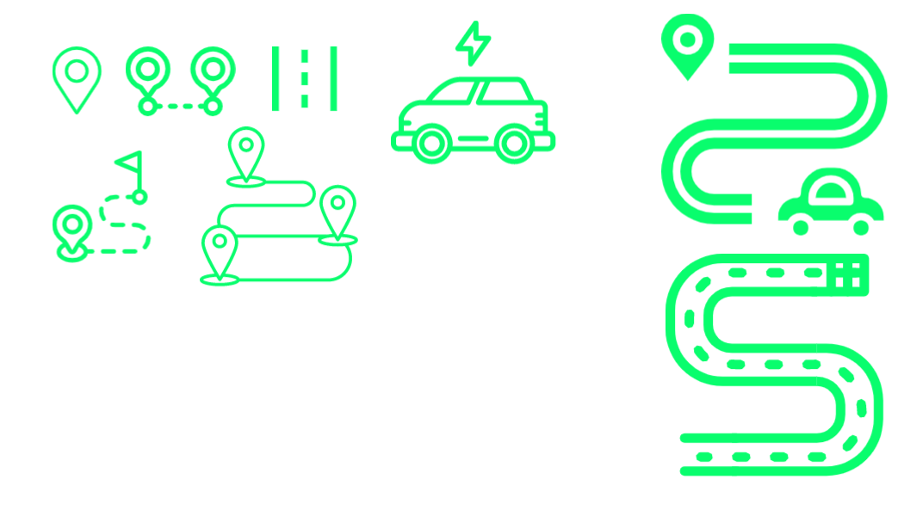

Curriculum Development Institute

Education Bureau HKSAR ©2022